Design and implementation of a Local Area Network (LAN)

using CISCO Packet Tracer



Department of Computer Engineering
Group Members : -
1. Danish Solkar (24111590805)
2. Kalam Khan (24111590782)
3. Jareer Khan (24111590791)
4. Saud Kazi (24111590790)

INDEX
Sr. no. | Topic | Page no.
1 | Introduction | 3
2 | Output | 4
3 | Application | 5
4 | Conclusion | 6
5 | References | 6

1. INTRODUCTION
A Local Area Network (LAN) is a network that connects computers and devices within a small geographical area such as a classroom, office, or home. It allows devices to communicate with each other and share resources like files, printers, and internet connections. LAN networks are commonly used because they provide fast communication and efficient resource sharing.

In this project, a LAN is designed and simulated using Cisco Packet Tracer. Multiple devices such as PCs and laptops are connected through a switch to create the network. The switch acts as the central device that allows all connected systems to communicate with each other.

This simulation helps in understanding how networking devices are connected and how data travels between different systems in a LAN. It also demonstrates basic network communication and connectivity testing.

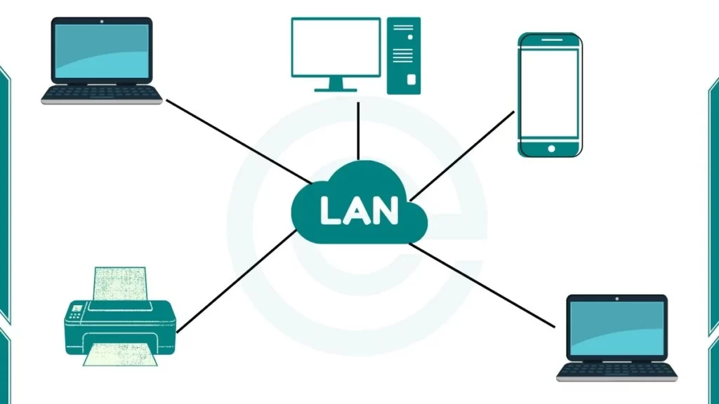

2. OUTPUT

The LAN network was successfully created using one 2960 switch, two PCs, and two laptops. All devices were connected to the switch using Ethernet cables. After assigning IP addresses to the devices, communication between them was tested using the ping command. The simulation confirmed that data packets were successfully transmitted between the devices, showing that the LAN network was functioning correctly.

The network topology consists of:

• 1 Switch

• 2 Personal Computers (PCs)

• 2 Laptops

• Ethernet connections between devices and switch

The successful ICMP ping test indicates that the devices are properly connected and able to communicate within the network.
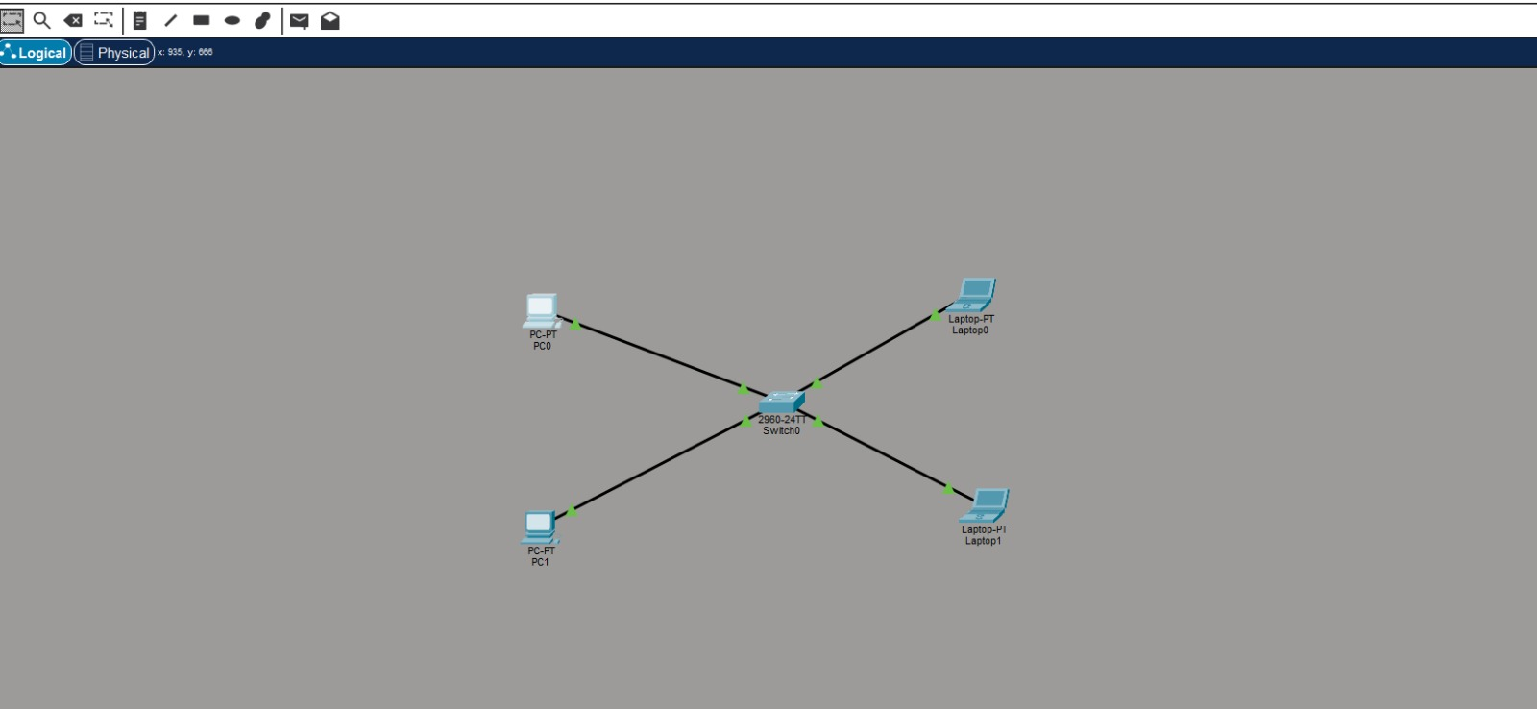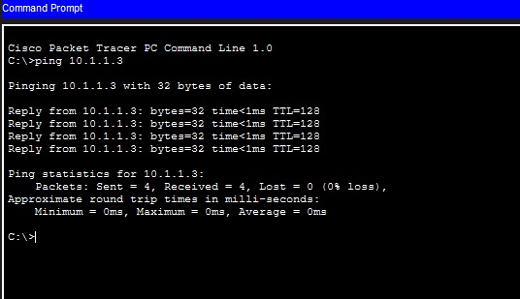

3. Applications

The LAN network designed in this project can be used in several real-world environments where multiple computers need to communicate and share resources efficiently.
• Schools and Colleges: LAN networks are used to connect computers in laboratories so that students and teachers can share files, access learning resources, and use common printers and internet connections.
• Offices: In offices, LAN allows employees to share documents, printers, and databases. It also helps in faster communication and efficient data management within the organization.
• Homes: A LAN can connect multiple devices such as laptops, PCs, and other smart devices, allowing family members to share files and use the same internet connection.
• Organizations and Companies: Large organizations use LAN networks for internal communication, data transfer, and accessing shared applications and servers.
Overall, LAN networks improve communication speed, make resource sharing easier between connected devices, and help in managing data efficiently within a limited area.

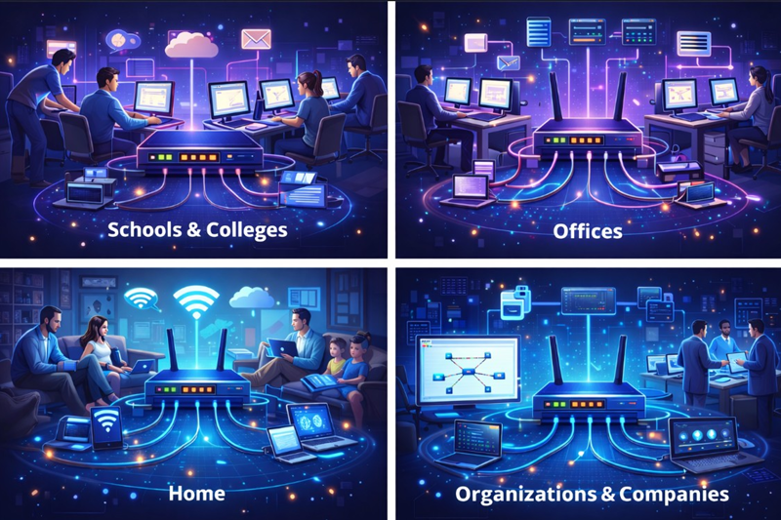

4. CONCLUSION

This project demonstrated the design and simulation of a Local Area Network (LAN) using Cisco Packet Tracer. By connecting multiple devices such as PCs and laptops through a switch, a simple LAN topology was successfully created. Proper connections were established and communication between the devices was tested.
The project helped in understanding the basic concepts of networking, such as device connectivity, network topology, and data communication between systems. It also showed how switches help devices in a LAN communicate efficiently.
Overall, this project provided practical knowledge about how LAN networks are created and how they work in real-life environments like schools, offices, and homes. It also improved understanding of network simulation tools and basic network configuration

5. REFERENCES

1.Cisco Networking Academy
2.Cisco Packet Tracer Software
3.Data Communication and Networking textbook
4.Online networking tutorials

